#
# 20170908
# It’s a link how to connect to Dell SupportAssist 2.3 after it was updated from 2.1.
https://vm-dell-ome01t.tcsbank.ru:5700/SupportAssist/resx/index.html#/

# Documentation.
http://www.dell.com/support/manuals/ru/ru/rudhs1/supportassist-enterprise-v1.1/sae11ug

http://en.community.dell.com/techcenter/systems-management/w/wiki/1989.openmanage-essentials/

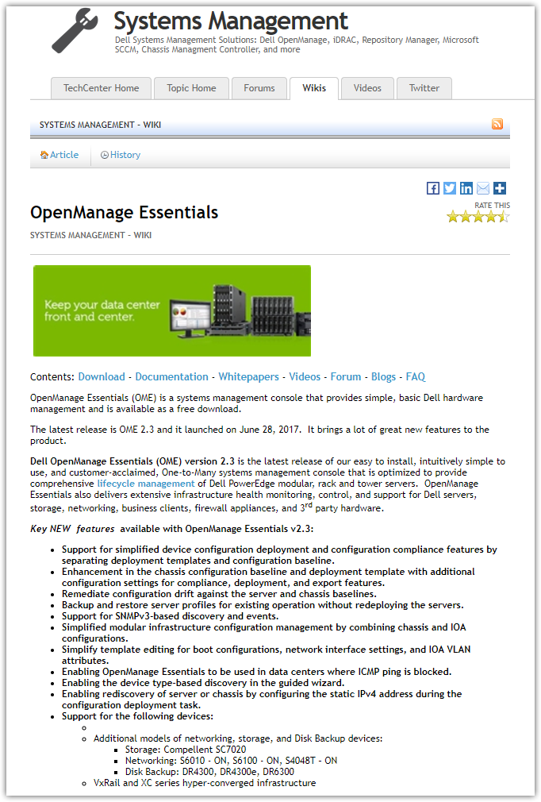
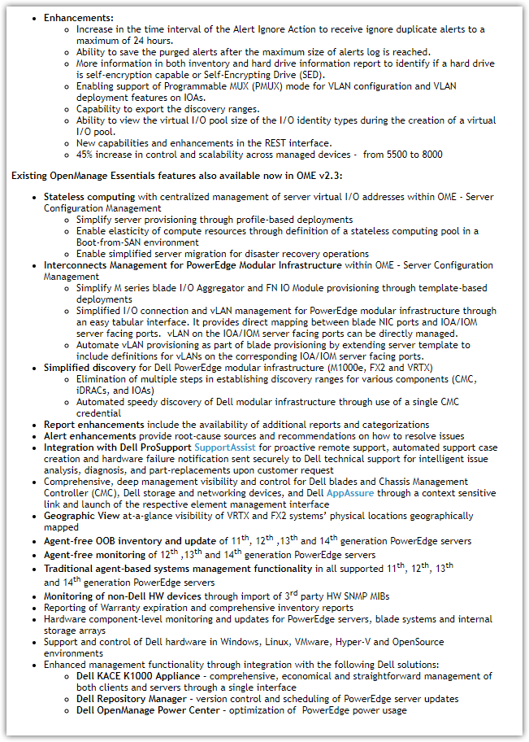
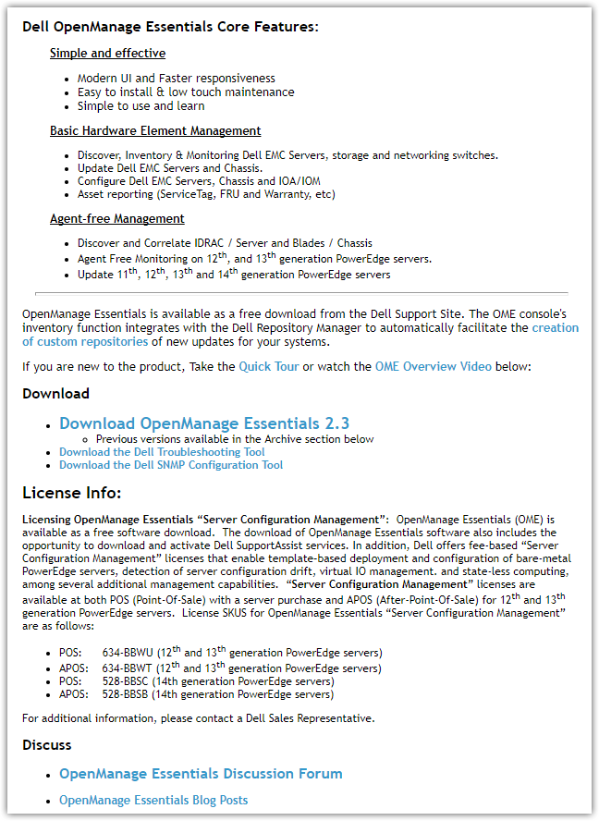
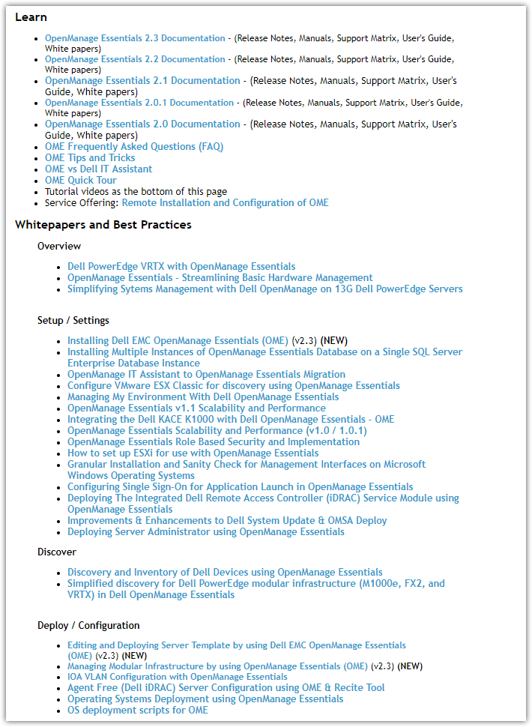
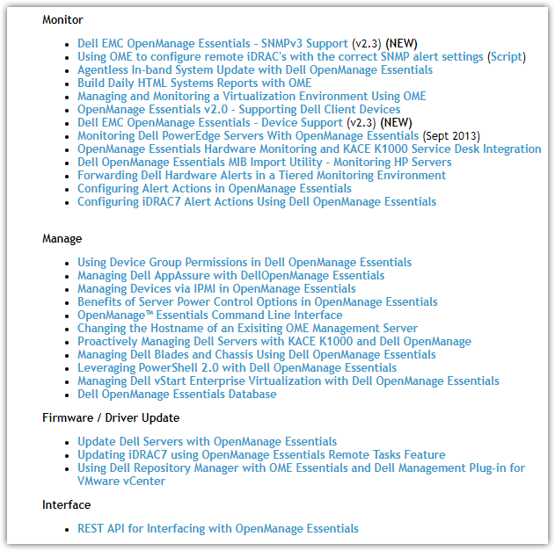

http://www.dell.com/support/home/ru/ru/rudhs1/Drivers/DriversDetails?driverId=5G6PK

